加州大学伯克利分校学分课程正式报名通知
我校与加州大学伯克利分校合作的学分课程预计将于4月正式开始，于6月上旬结束，共开设以下课程：

- Psychology and Ethical Behavior: Doing the Right Thing
- Envisioning Future Communities with S.T.E.A.M. focus
- Digital Storytelling

上课地点为南外本部，每门课程总课时45小时， 每周一、四、五上课。
Psychology: Doing the Right Thing 从4月11日开始上课
Envisioning Future Communities with S.T.E.A.M. focus、Digital Storytelling 从4月20日开始上课
具体课程表如下：

Time | Course | Instructor
9:00 - 11:00 | Psychology: Doing the Right Thing | John
12:40 – 14:40 | Envisioning Future Communities with S.T.E.A.M. focus | Abigail
15:00 – 17:00 | Digital Storytelling | Abigail

报名流程如下：

- 网上注册
Students, will need to create your profiles at https://extension.berkeley.edu You should go to "Log In" on the left hand side, then create the account under "Student Log In":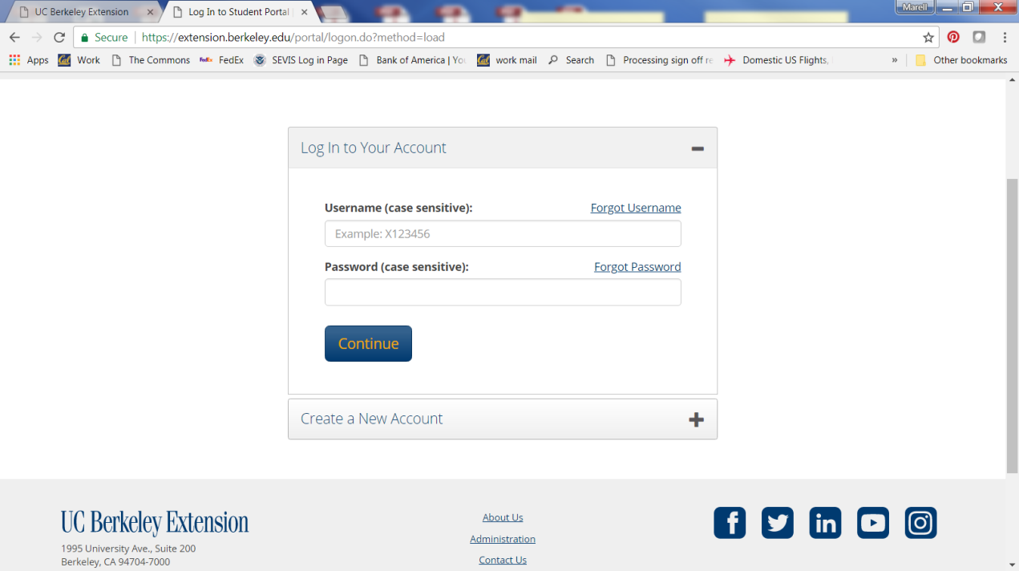

The profile has required fields: name as it appears on the passport, DOB, gender, home permanent address, home permanent phone number and email.
You will need to also enter under the "Group Affiliations" this number G000711 so your accounts will be associated with NFLS.
The course is not "open enrollment" so you will not be able to select the course to purchase on this website. When we have a list of student names for each course and we can then enroll the students and invoice you. Once you receive an invoice you will need to go back into their accounts to purchase the course, so please make sure you remember your passwords!

- 伯克利课程学生信息表（见附录）交学校外办或网上传给负责老师

请加入QQ群“2018伯克利课程”（群号：316151781），在4月11日前将填写完的信息表交至行政楼外事办公室（401）或发送电子版至上述QQ群。

请注意，以上两项流程务必全部完成，否则无法完成报名。

南京外国语学校外事办公室

伯克利课程学生信息表

姓名
出生日期
家庭住址
邮箱
电话（本人及父母）
QQ
班级
选择课程  （可多选） | - Psychology: Doing the Right Thing (9:00 - 11:00)  - Envisioning Future Communities with S.T.E.A.M. focus (12:40 – 14:40)  - Digital Storytelling (15:00 – 17:00)
是否已经在伯克利网站完成注册

